**Sentiment Based Music Recommendation System**

Preetika Sastry

*TY B.Tech Computer Science and Engineering*  
Dr. Vishwanath Karad MIT World Peace UnivsersityPune, India

Shranay Shahane

*TY B.Tech Computer Science and Engineering*  
Dr. Vishwanath Karad MIT World Peace UnivsersityPune, India

Adnan Shoaib Nazmuddin

*TY B.Tech Computer Science and Engineering*  
Dr. Vishwanath Karad MIT World Peace UnivsersityPune, India

Mananya Saxena

*TY B.Tech Computer Science and Engineering*  
Dr. Vishwanath Karad MIT World Peace UnivsersityPune, India

*Abstract*— Social Media and Music both are a big part of life these days. Our system will work by automatically beginning the Social Media Analysis through various social media APIs. These APIs will give us access to the User’s social media activity in the form of text posts, tweets, etc. From the extracted data our model will identify emotion and categorize the User as sad/happy based on the most dominantly observed emotion. The detected emotion is then used to filter out songs that match that emotion in the Music Collection Database. Amongst these sentiment matched songs algorithms are performed that identify which of these songs the User would like the most based on their historically identified preferences. These songs are then presented to the User as recommendations

Keywords—Music, Sentiment, Recommendation, Social Media

# Introduction

# Nowadays, music platforms provide easy access to large amounts of music. They are working continuously to improve music organization and search management thereby addressing the problem of choice and simplify exploring new music pieces. Recommendation systems gain more and more popularity and help people to select appropriate music for all occasions. However, there is still a gap in personalization and emotions driven recommendations. Music has a great influence on humans and is widely used for relaxing, mood regulation, destruction from stress and diseases, to maintain mental and physical work. There is a wide range of clinical settings and practices in music therapy for wellbeing support.

With the development of digital music technology, the development of a personalized music recommendation system which recommends music for users is essential. It is a big challenge to provide recommendations from the large data available on the internet. E-commerce giants like Amazon, eBay provide personalized recommendations to users based on their taste and history while companies like Spotify, Pandora use Machine Learning and Deep Learning techniques for providing appropriate recommendations. In this project, we present the design of the personalized music recommendation system, driven by the listener’s preferences as well as emotions. With a combination of ML algorithms, Python Libraries and generalized music therapy approaches, a recommendation system is targeted to help people with music

selection for different life situations and maintain their mental and physical conditions.

1. Purpose:

In our proposed project, a music recommendation system is created which performs the usual task of recommending songs the user would like based on his/her history with the added benefit of also catering to the user’s current mood. This recommendation system becomes an additional feature to the traditional music players. An important benefit of incorporating mood detection is customer satisfaction. Mood based music recommendation helps to suggest songs more accurately and avoids cases of user skipping a song where the song would have been liked by user if he was in better or worse mood.

1. Scope:

By developing such a recommendation system, a user will be able to quickly decide on music that could either match their mood. Music is an extremely important part of everyone’s daily life and has the power to affect a person’s mental health drastically. Being shown music with relatable lyrics can be a source of comfort or uplift a happy user’s mood even more. If the user is sad and wants to be uplifted then they could choose to be shown uplifting music that can make them feel more positive and hopeful. As of now our team is focusing on just 2 sentiments, i.e. happy or sad, but this project could easily be expanded to cover more complex emotions such as stressed, sleepy, energetic, etc.

1. Objective:

## To successfully analyse the user’s social media activity and predict the mood of the user based on it

## To accurately suggest songs suitable to the detected mood and preference

## To recommend the most suitable and tailored top songs to the user based on previous preferences

## Problem Statement

## To create a system that recommends music based on the user's current emotional state

## Scope

Scope of our project is to build a model for sentiment analysis of the user’s mood and appropriate recommendation of music based on that mood

# Related Work/Literature Survey

|  |  |  |  |
| --- | --- | --- | --- |
| Sr no. | Paper Title | Paper Link | About |
| 2 | Music Recommendation System based on Emotions in User’s Social Media behaviour. | <https://doi.org/10.36227/techrxiv.14493828.v1> | This paper suggests use of sentiment analysis classification as an effective method for examining textual data coming from variety of resources on internet. |
| 3 | An Approach to Integrating Sentiment Analysis into Recommender Systems | Dang, &amp; Moreno , &amp; De La , Fernando. (2021). An Approach to Integrating Sentiment Analysis into Systems. Sensors. 21. 5666. 10.3390/s21165666 | This paper is an approach into achieving greater user personalisation experience by integrating sentiment analysis into the already widely used music recommendation systems |
| 4 | A Novel Emotion-Aware Hybrid Music Recommendation Method Using Deep Neural Network. | Wang, S.; Xu, C.; Ding, A.S.; Tang, Z. A Novel Emotion-Aware Hybrid Music Recommendation Method Using Deep Neural Network. Electronics 2021, 10, 1769. https:/doi.org/10.3390/electronics10151769 | The two models were trained using a designed deep neural network architecture  (emoDNN) to predict the music emotions for the music and the music emotion preferences for the  users in a continuous form. |
| 5 | Sentiment Analysis for Social Networks Using Machine Learning Techniques. | [Sudarsa, Dorababu & Pathuri, Siva Kumar & Rao, L.. (2018). Sentiment Analysis for Social Networks Using Machine Learning Techniques. International Journal of Engineering and Technology(UAE). 7. 473-476. 10.14419/ijet.v7i2.32.16271.bigdata.springeropen.com/articles/10.1186/s40537-015-0015-2](https://journalofbigdata.springeropen.com/articles/10.1186/s40537-015-0015-2) | In this paper, the researchers aim to tackle the problem of sentiment polarity categorization Data used in this study are online product reviews collected from Amazon.com. |
| 6 | Music Recommendation System Based on User's Sentiments Extracted from Social Networks. | [Rosa, Renata & Rodriguez, Demostenes Zegarra & Bressan, Graca. (2015). Music Recommendation System Based on User's Sentiments Extracted from Social Networks. IEEE Transactions on Consumer Electronics. 61. 359-367. 10.1109/TCE.2015.7298296.](https://www.koreascience.or.kr/article/JAKO202118248643510.pdf) | Pre-prepared the dataset, after that extract the adjective from the dataset that has a couple of significance this is alluded to as capacity vector, at that point decided on the component vector posting and from that point accomplished device examining based write calculations particularly navie bayes, most entropy and svm along the edge of the semantic introduction based absolutely based on word net which extracts synonyms and similarity for the content characteristic. |
| 7 | Sentiment Analysis for Social Media | [Jayasanka, Sachira & Madhushani, Thilina & Marcus, E. & Aberathne, I. & Premaratne, Saminda. (2013). Sentiment Analysis for Social Media.ttps://www.msi.org/wp-content/uploads/2020/06/MSI_SR_10-202.pdf](https://www.msi.org/wp-content/uploads/2020/06/MSI_SR_10-202.pdf) | In this paper we discuss some of the challenges in sentiment extraction, some of the approaches that have been taken to address these challenges and our approach that analyses sentiments from Twitter social media which gives the output beyond just the polarity but use those polarities in product profiling, trend analysis and forecasting. |
| 8 | Hybrid Recommender Systems: A Systematic Literature Review | [Çano, Erion; Morisio, Maurizio (2017). Hybrid Recommender Systems: A Systematic Literature Review. In: INTELLIGENT DATA ANALYSIS, vol. 21 n. 6, pp. 1487-1524. - ISSN 1088-467X](https://par.nsf.gov/biblio/10165854) | This systematic literature review presents the state of the art in hybrid recommender systems of the last decade. It is the first quantitative review work completely focused in hybrid recommenders. |

# Dataset and features

User Data was collected from the following Social Media Platforms using various scraping tools:

1. Instagram

Celebrity Instagram pages were scraped for data in their most recent posts/captions using apify Instagram Scraper

1. Facebook:
2. Twitter
3. LinkedIn

# Architecture, Methods/ learning algorithms

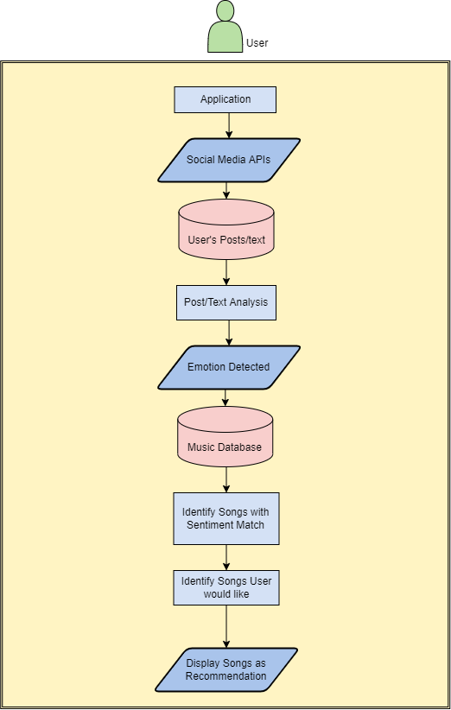

Our system will work by automatically beginning the Social Media Analysis through various social media APIs. These APIs will give us access to the User’s social media activity in the form of text posts, tweets, etc. From the extracted data our model will identify emotion and categorize the User as sad/happy based on the most dominantly observed emotion. The detected emotion is then used to filter out songs that match that emotion in the Music Collection Database. Amongst these sentiment matched songs algorithms are performed that identify which of these songs the User would like the most based on their historically identified preferences.

These songs are then presented to the User as recommendations

# Results

The stacking of the Sentiment Analysis Model on top of the Recommendation System model resulted in better user experience and closer personalization. The project serves as encouragement towards the future of combining various machine learning models to enhance recommendations. Showing the combination of models working in music systems can serve as motivation for them to also be applied to video streaming recommendations, youtube recommender systems, content recommendation systems, etc.

# future work

Our project focuses on identifying just 2 main sentiments i.e. happy or sad. Expanding on this model, in the future we can identify more complex emotions such as ‘energetic’, ‘stressed’, ‘depressed’, etc and provide recommendations for the same. The stacked model system can be further stacked to provide recommendations based on even more factors such as user location or recent activity.

##### References

1. Perera, Ravidu (2021): Music Recommendation System based on Emotions in User’s Social Media behaviour. TechRxiv. Preprint. https://doi.org/10.36227/techrxiv.14493828.v1 Mostafa, Mohamed M. . More than words: Social networks’ text mining for consumer brand sentiments. 2013
2. Rosa, Renata & Rodriguez, Demostenes Zegarra & Bressan, Graca. (2015). Music Recommendation System Based on User's Sentiments Extracted from Social Networks. IEEE Transactions on Consumer Electronics. 61. 359-367. 10.1109/TCE.2015.7298296.
3. Akuma, S., Obilikwu, P., & Ahar, E. (2021). Sentiment Analysis of Social Media Content for Music Recommendation. NIGERIAN ANNALS OF PURE AND APPLIED SCIENCES, 4(1), 95–102. <https://doi.org/10.46912/napas.225>
4. <https://towardsdatascience.com/how-to-analyze-emotions-and-words-of-the-lyrics-from-your-favorite-music-artist-bbca10411283>
5. <https://towardsdatascience.com/create-music-recommendation-system-using-python-ce5401317159>
6. <https://analyticsindiamag.com/beginners-guide-to-building-a-song-recommender-in-python/>
7. Jayasanka, Sachira & Madhushani, Thilina & Marcus, E. & Aberathne, I. & Premaratne, Saminda. (2013). Sentiment Analysis for Social Media.
8. Dang, Cach & Moreno García, María & De La Prieta, Fernando. (2021). An Approach to Integrating Sentiment Analysis into Recommender Systems. Sensors. 21. 5666. 10.3390/s21165666.
9. Sudarsa, Dorababu & Pathuri, Siva Kumar & Rao, L.. (2018). Sentiment Analysis for Social Networks Using Machine Learning Techniques
10. Wang, S.; Xu, C.; Ding, A.S.; Tang, Z. A Novel Emotion-Aware Hybrid Music Recommendation Method Using Deep Neural Network. Electronics 2021, 10, 1769. https://doi.org/10.3390/electronics10151769